Type of the Paper (Research article, Review, Rapid communication)

Title

First name Lastname¹, Fist name Last name^{2*}

¹Department of Convergence Science, Sahmyook University, Seoul, 01795, Republic of Korea  ²Plant Genetics and Breeding Institute, Sahmyook University, Seoul, 01795, Republic of Korea  *Corresponding to Gil Dong Hong  TEL. +82-2-0000-0000  E-mail. 0000@000.00.00 | Abstract Abstract is the second manuscript page and should not exceed 250 words. It should not include bibliographic, figure, or table references. Equations, formulas, obscure abbreviations, and acronyms also are inappropriate. The abstract should be followed by key words indicating the contents of the research paper.
 | Key words Keyword 1, Keyword 2, Keyword3, … [Capitalize the first letter of each key word]

Introduction
Phalaenopsis is a monopodial epiphytic orchid genus with a unique and attractive flower morphology. It is comprised of more than 70 species distributed in the subtropical and tropical countries of Southeast Asia. Phalaenopsis is a monopodial epiphytic orchid genus with a unique and attractive flower morphology. It is comprised of more than 70 species distributed in the subtropical and tropical countries of Southeast Asia.

[You cannot indent first paragraph, but second paragraph; In text, references should be listed in a year.
(e.g) In some cases ~ (Kim and Han 2001; Kang et al. 2009; Lee 2014)
(e.g) Kim et al. (2010) observed…
(e.g) The researches were… (Kim et al. 2008; Kim et al. 2009; Kim et al. 2014)]

Materials and Methods
Plant and cultivation (subtitle)
Phalaenopsis is a monopodial epiphytic orchid genus with a unique and attractive flower morphology. It is comprised of more than 70 species distributed in the subtropical and tropical countries of Southeast Asia. Phalaenopsis is a monopodial epiphytic orchid genus with a unique and attractive flower morphology. It is comprised of more than 70 species distributed in the subtropical and tropical countries of Southeast Asia.
Phalaenopsis is a monopodial epiphytic orchid genus with a unique and attractive flower morphology. It is comprised of more than 70 species distributed in the subtropical and tropical countries of Southeast Asia. Phalaenopsis is a monopodial epiphytic orchid genus with a unique and attractive flower morphology. (Manni et al., 2021;Stanke et al., 2006) It is comprised of more than 70 species distributed in the subtropical and tropical countries of Southeast Asia. Phalaenopsis is a monopodial epiphytic orchid genus with a unique and attractive flower morphology. It is comprised of more than 70 species distributed in the subtropical and tropical countries of Southeast Asia. Phalaenopsis is a monopodial epiphytic orchid genus with a unique and attractive flower morphology. It is comprised of more than 70 species distributed in the subtropical and tropical countries of Southeast Asia. (Shen et al., 2016)

Subtitle 2
Phalaenopsis is a monopodial epiphytic orchid genus with a unique and attractive flower morphology. It is comprised of more than 70 species distributed in the subtropical and tropical countries of Southeast Asia. Phalaenopsis is a monopodial epiphytic orchid genus with a unique and attractive flower morphology. It is comprised of more than 70 species distributed in the subtropical and tropical countries of Southeast Asia. Phalaenopsis is a monopodial epiphytic orchid genus with a unique and attractive flower morphology. It is comprised of more than 70 species distributed in the subtropical and tropical countries of Southeast Asia. Phalaenopsis is a monopodial epiphytic orchid genus with a unique and attractive flower morphology. It is comprised of more than 70 species distributed in the subtropical and tropical countries of Southeast Asia. (Xue et al., 2008)

[Materials and Methods should include enough detail so that a competent scientist can repeat the experiments. Methods should be cited by a reference if well-known methods were used.
Nomenclature. Common name, Latin binomial or trinomial (in italics), and the authority for all plants, insects, and pathogens should be given at first mention in the abstract or text. Crop cultivars must be identified by single quotation marks when first in the abstract or text unless cultivar status is already clear (e.g., identified by the word cultivar or the abbreviation cv).
Units of Measurement. All measurements should be in metric units.
Only SI units are allowed to be used. Please use abbreviation of words (μL) instead of using mark (㎕); Abbreviations for time unit are not allowed [e.g, min. (X) → minutes (O)]
In addition to SI units, non SI unit such as diagonal line (/) percent (%), degree (℃) also can be used. For experimental machine, please mention model, manufacturer, country.]

Results
Subtitle 1
Out of the 208 F2 plants, 155 plants showed longer hairs similar to CH4 and 53 plants showed shorter hairs following HA. This ratio of pubescence shows that the trait is controlled by one dominant gene following Mendelian genetics as verified using a chi-squared test at df = 1 (Table 1).

Subtitle 2
A total of 10 plants for each distinct phenotype was prepared in bulk as source material for DNA collection. Differences between the two parents were also compared to obtain multiple SNP-index level. Total SNP-index level was calculated by subtracting the SNP-index values. Raw NGS data were processed using Python (Sugihara et al. 2022). The threshold limit was set to 99% confidence for the selection of candidate regions and SNPs. The candidate region (qHL6) showing a SNP-index score of over 0.5 was identified to be between 24.8Mb and 29.8 Mb in chromosome 6 (Fig. 2a).

[In text, table and figures can be mentioned as below;
(ex) Table 3 and Fig. 2 were …
(ex) Rooting increased under higher light intensities (Fig. 2).]

Table 1. Write Table description here.
Cross | QTL | Chr. | Marker | P value | R² | Mean^{z}
 |  |  |  |  |  | HH | GH/HR | GG/RR
tgw2/gw9.1 | tgw2 | 2 | RM12813 | <0.0001 | 0.73 | 22.3b^{y} | 24.3b | 26.8a
tgw2/gw9.1 | gw9.1 | 9 | ex9 | 0.01 | 0.39 | 22.3b | 22.8ab | 23.9a
[The table should be divided between the table head (for basic information) and notes (for significance, notation and definition, or procedure). Use the shoulder letters ^{z)}, ^{y)}, ^{x)}, ^{w)}, ^{v)}, ^{u)}, ^{t)}, ^{s)}, ^{r)}.... The shoulder letters or numbers should be cited left to right and top to bottom in the table. The *, **, and *** are always used in this order to show statistical significance at the 0.05, 0.01, and 0.001 probability levels, respectively, and cannot be used for any other footnote. The acronyms should be spelled out in the legends.]

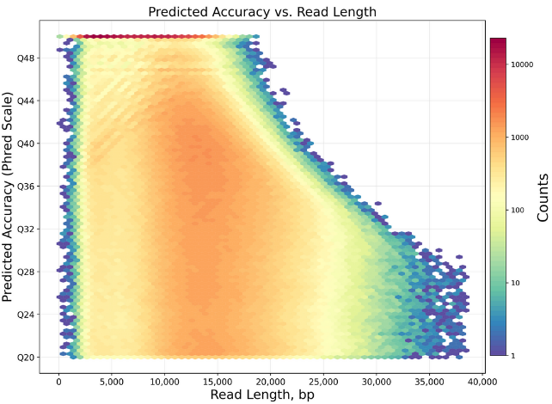 | 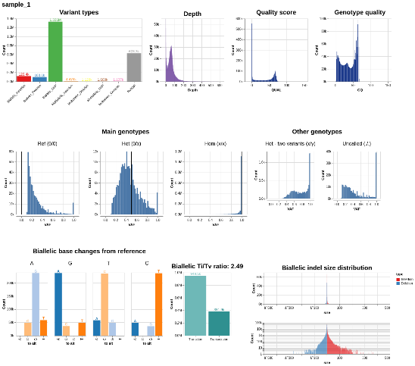
(a) | (b)
Fig. 1. Write Figure Description here. Describe (a) and (b), Figures and Tables should be near with its content.
Discussion
Subtitle 1
Narrowed-down results using indel markers show pubescence gene is place between Indel-102 and Indel-115. The size of region is around 203.56 Kbp. Within the specified region, a published gene controlling pubescence named HL6 (Os06g0657500) exists on 203.56 Kbp region. (Sun et al. 2017; Fig. 2b). According to existing studies, HL6 was identified to be related to trichome formation which is regulated by the AP2/ERF transcription factor. This gene regulates trichome elongation by interaction with OsWOX3B, a homeodomain-containing protein related to the initiation of trichome formation. Our results confirmed that HL6 located in chromosome 6 showed direct functions to control the glabrous leaf phenotype in the Indica and Japonica rice subspecies contrary to the BKL which controls this phenotype in wild rice (Oryza nivara). In this study, we analyzed sequences of HL6 in CH4 and HA to search which exons in HL6 are directly affecting hair length production.

Subtitle 2
To search which exon is related to pubescence, resequencing and haplotype analysis for the exons of HL6 in CH4, HA, and IRGSP1.0 (used as reference) were compared. Between CH4 and HA, 9 SNPs and 6 deletions were detected. A total of seven alterations of SNPs are responsible for changes in the translated amino acid sequence (Fig. 2c).

[For Research article, “Result” and “Discussion” section should be separated. Rapid communication should have combined form “Result and Discussion”. Review article has no such regulations.]
Acknowledgments
This work was supported by the Cooperative Research Program for Agriculture Science and Technology Development (Project No. 00000000) of the Rural Development Administration of the Republic of Korea.

References
Manni M, Berkeley MR, Seppey M, Simão FA and Zdobnov EM. 2021. BUSCO Update: Novel and Streamlined Workflows along with Broader and Deeper Phylogenetic Coverage for Scoring of Eukaryotic, Prokaryotic, and Viral Genomes. Mol. Biol. Evol. 38(10):4647-4654.
Shen W, Le S, Li Y and Hu F. 2016. SeqKit: A Cross-Platform and Ultrafast Toolkit for FASTA/Q File Manipulation. PLOS ONE 11(10):e0163962.
Stanke M, Keller O, Gunduz I, Hayes A, Waack S and Morgenstern B. 2006. AUGUSTUS: ab initio prediction of alternative transcripts. Nucleic Acids Res. 34(suppl_2):W435-W439.
Xue W, Xing Y, Weng X, Zhao Y, Tang W, Wang L, et al. 2008. Natural variation in Ghd7 is an important regulator of heading date and yield potential in rice. Nat. Genet. 40(6):761-767.
Author (Exceeding 6 authors should use “, et al.” from 7th author.) Year. Title. Journal name. Vol. Page.

[References should be written as suggested below. Journal names should be written with abbreviation, journals with no abbreviation shoulb be written with full name and no period mark at the end of names. Layout of references are provided as Endnote format in the journal main page or authors instructions. If authors have no Endnote, Follow the format we suggest in this instructions. (We recommand to update Endnote “Journal term list” importing “Bioscience” which Endnote provide to use correct abbreviations)]

